**Idea:** Use these IMU signals (after resampling them to the audio sampling rate) as **reference inputs to the LMS filter** to estimate the noise component due to engine, and subtract it from the audio.

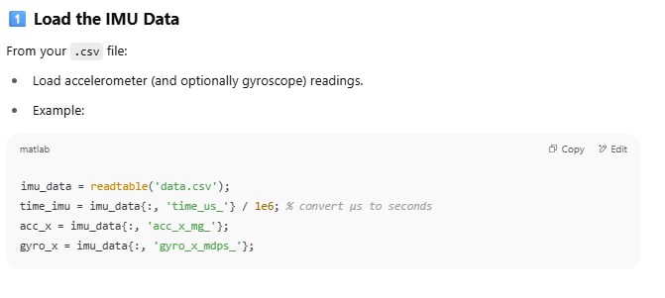

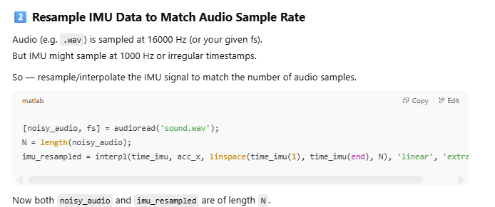

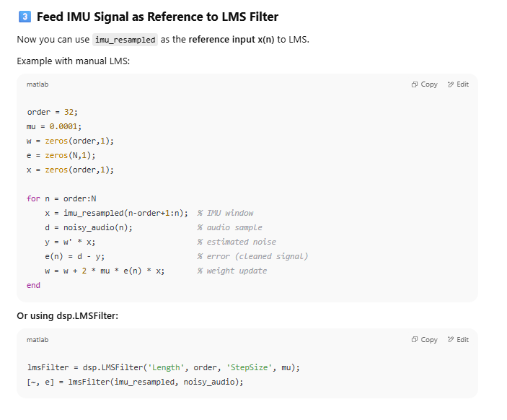

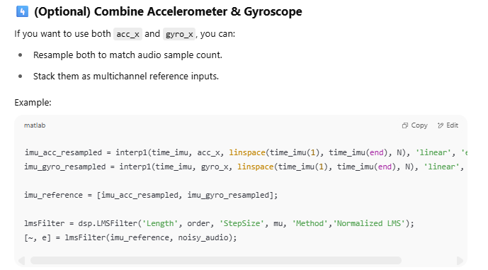

Summary Workflow

